Day 2

**TASK: 01**

**Create directories which would have the following structure by using only mkdir command:**

**HIERARCHY:**

consultadd/

|-- Python

|   `-- Django

|       `-- restframework

|-- java

|   `-- springboot

|-- javascript

|   `-- angular

|   `-- react

|-- SQL

|   `-- mysql

`-- bootcamp

**HINT :** Use mkdir command in single line

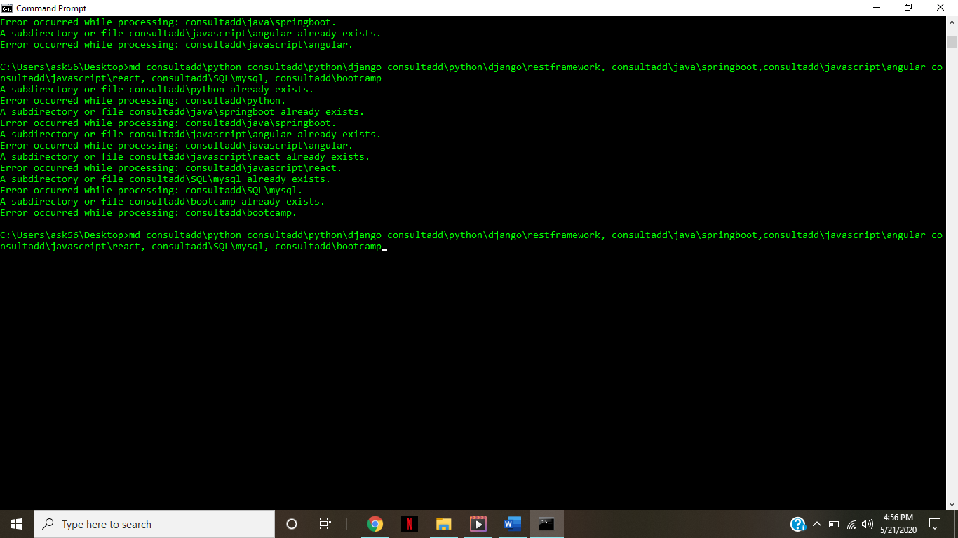

**TASK 02:**

* Create Directory called consultadd

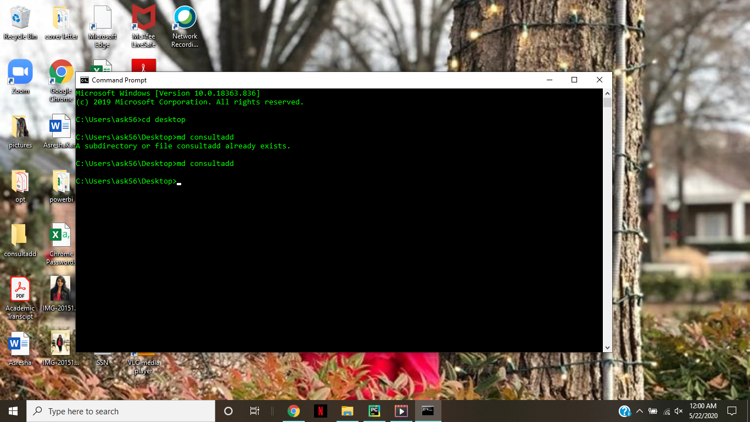

* Inside that create 5 more directories named them as dir1, dir2, dir3, dir4 and dir5
* What would be the output of Long Listing after creating these directories?

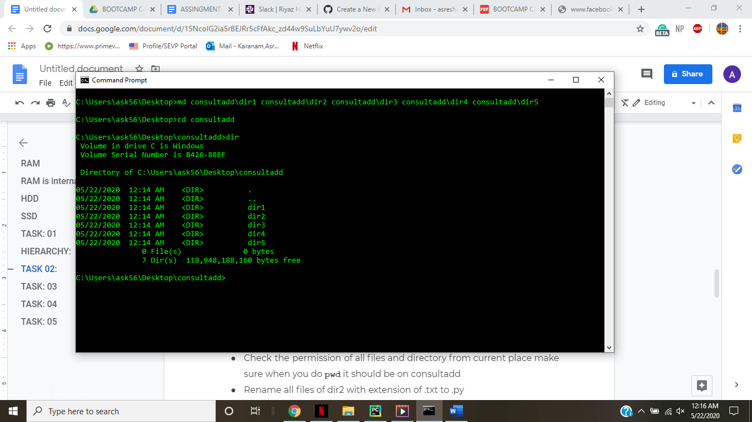

* List all the directories with ls and echo * and see the difference.

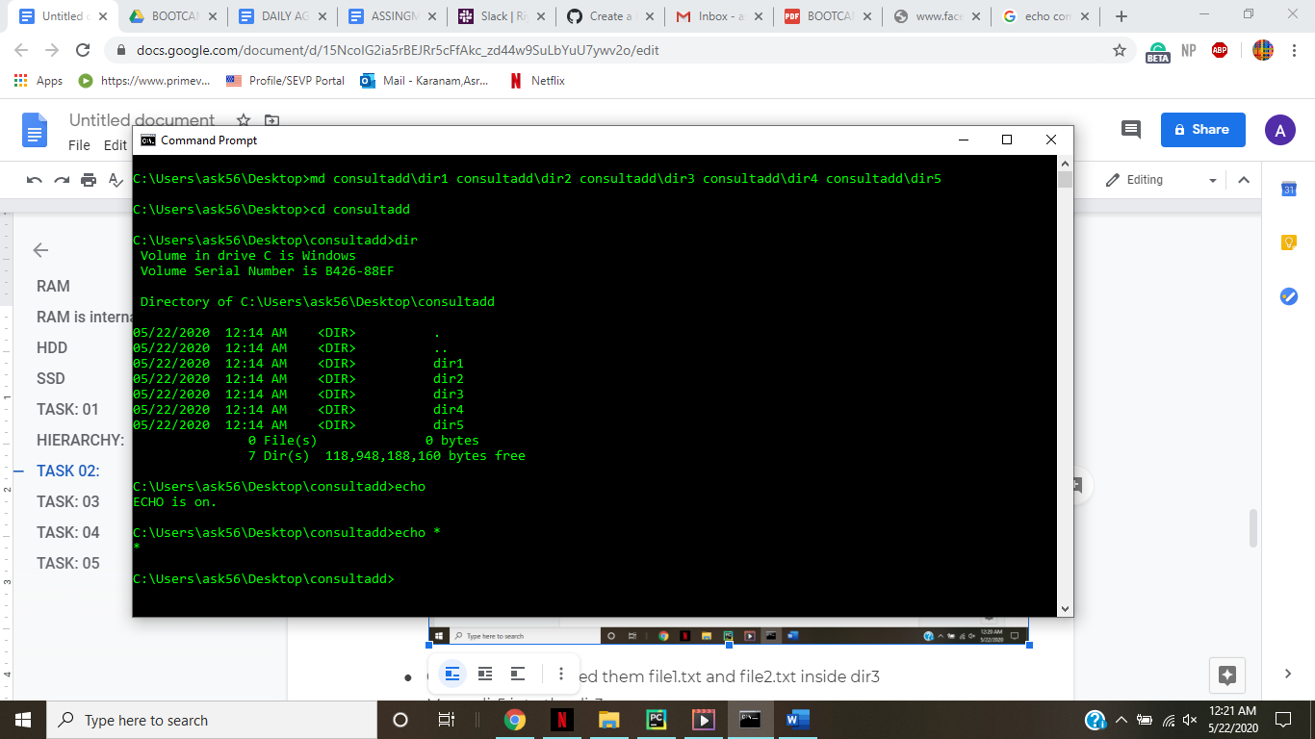

* Create a 2 files named them file1.txt and file2.txt inside dir3

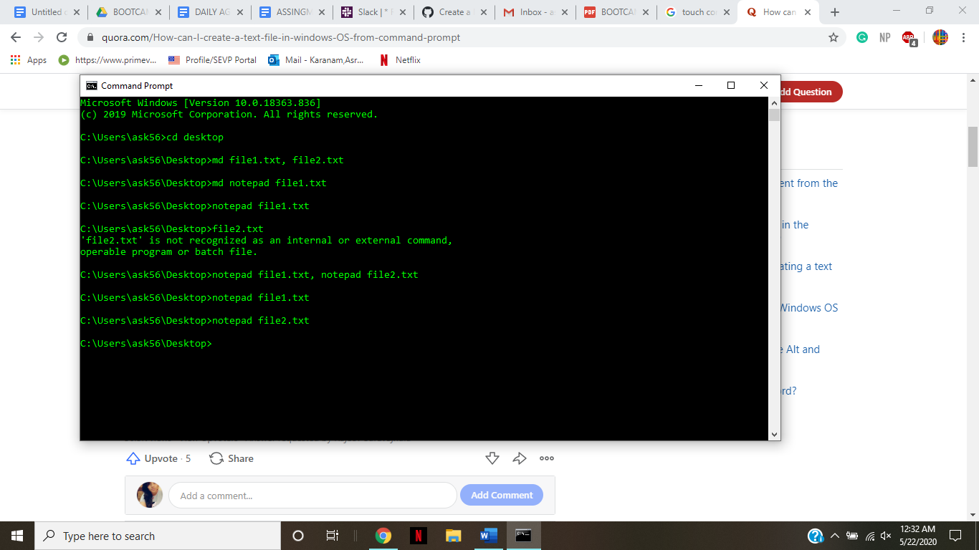

* Move  dir5 into the dir3

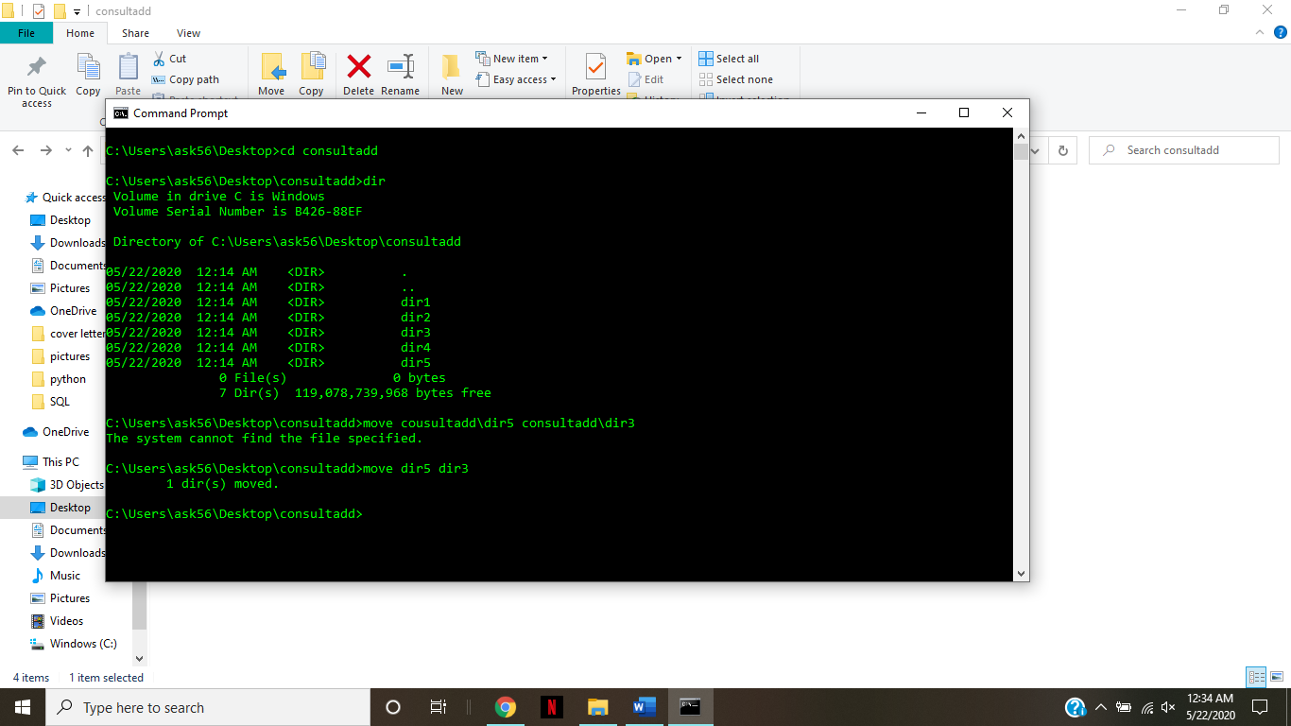

* Remove dir 3 after moving all files from dir3 to dir2.

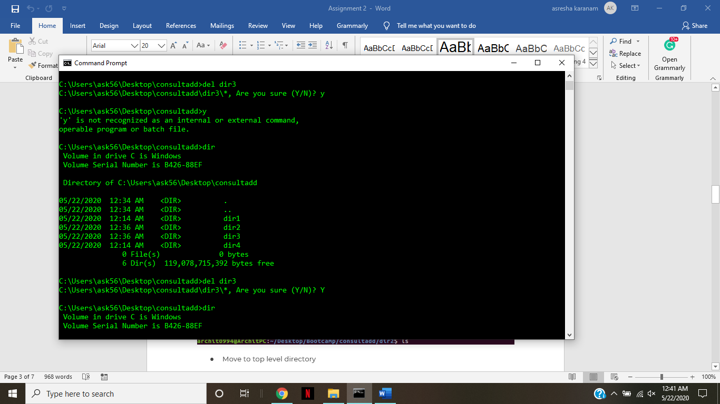

* Go to the dir2 and create one more file with name index.html

Doubt

* Move to top level directory
* Check the permission of all files and directory from current place make sure when you do **pwd** it should be on consultadd
* Rename all files of dir2 with extension of .txt to .py

**HINT:** Use Rename  command - Make sure you install it first.

**TASK: 03**

* What is Nano Editor?

It is an easy to use command line text editor for Unix and Linux operating systems. It includes all the basic functionality you'd expect from a regular text editor, like syntax highlighting, multiple buffers, search and replace.

* + How to create a sample file in Nano Editor?

Using CMD windows

* + How to save file?

**Ctrl+x**

* What is Vi Editor?

**Vi** is a screen **editor** for Linux, Unix and other Unix-like operating systems.It is a widely-used default text **editor** for Unix-based systems and is shipped with virtually all versions of Unix.

* + Operation in Vi Editor

The **vi editor** has three **modes of operation** viz. the command **mode**, the insert **mode**, and the ex-command **mode**

**TASK: 04**

* Type **finger** to see your account and name.
* Type **cal** to see this month’s calendar.
* Create a file and give a name random.txt to it with content into it which say “Hello Welcome to the Consultadd Inc Bootcamp”.
* Display the same content using **cat** command.

**TASK: 05**

* Explain the workflow of the Internet in one paragraph.

Physically, the Internet uses a portion of the total resources of the currently existing public telecommunication networks. Technically, what distinguishes the Internet is its use of a set of protocols called Transmission Control Protocol/Internet Protocol (TCP/IP). Two recent adaptations of Internet technology, the intranet and the extranet, also make use of the TCP/IP protocol.

The Internet can be seen as having two major components: network protocols and hardware. The protocols, such as the TCP/IP suite, present sets of rules that devices must follow in order to complete tasks. Without this common collection of rules, machines would not be able to communicate.

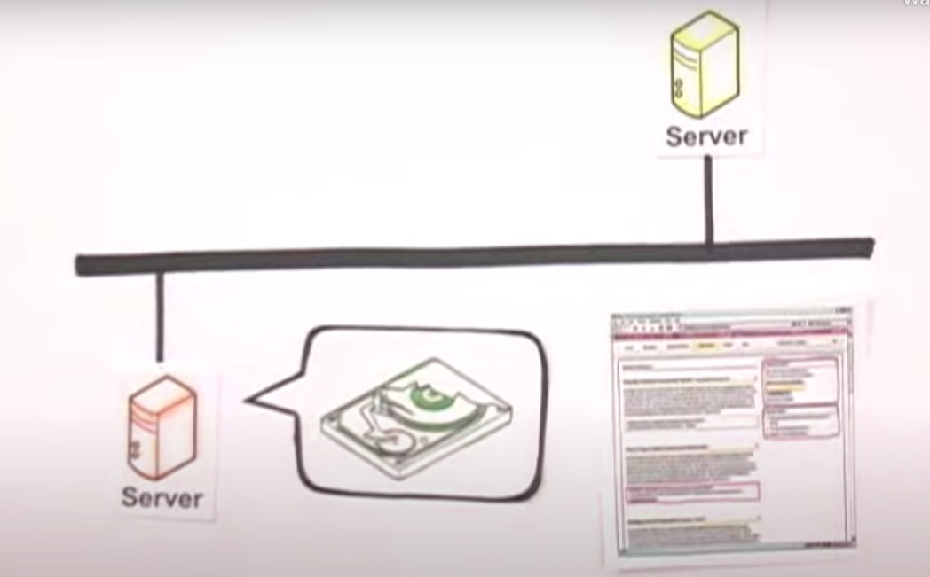

The protocols are also responsible for translating the alphabetic text of a message into electronic signals that can be transmitted over the Internet, and then back again into legible, alphabetic text. Hardware, the second major component of the Internet, includes everything from the computer or smartphone that is used to access the Internet to the cables that carry information from one device to another. Additional types of hardware include satellites, radios, cell phone towers, routers and servers. These various types of hardware are the connections within the network. Devices such as computers, smartphones and laptops are end points, or clients, while the machines that store the information are the servers. The transmission lines that exchange the data can either be wireless signals from satellites or 4G and cell phone towers, or physical lines, such as cables and fiber optics. The process of transferring information from once device to another relies on packet switching. Each computer connected to the Internet is assigned a unique IP address that allows the device to be recognized. When one device attempts to send a message to another device, the data is sent over the Internet in the form of manageable packets. Each packet is assigned a port number that will connect it to its endpoint. A packet that has both a unique IP address and port number can be translated from alphabetic text into electronic signals by travelling through the layers of the OSI model from the top application layer to the bottom physical layer. The message will then be sent over the Internet where it is received by the Internet service provider's (ISP) router. The router will examine the destination address assigned to each packet and determine where to send it. Eventually, the packet reaches the client and travels in reverse from the bottom physical layer of the OSI model to the top application layer. During this process, the routing data -- the port number and IP address -- is stripped from the packet, thus allowing the data to be translated back into alphabetic text and completing the transmission process.

* How LAN is different from the WAN network?